UI Release 10.5.4

This document contains screenshots of the release.

FR-681 UI - Ability to search for items by SKU on entire platform
Search by SKU on all vendors for review in Orders
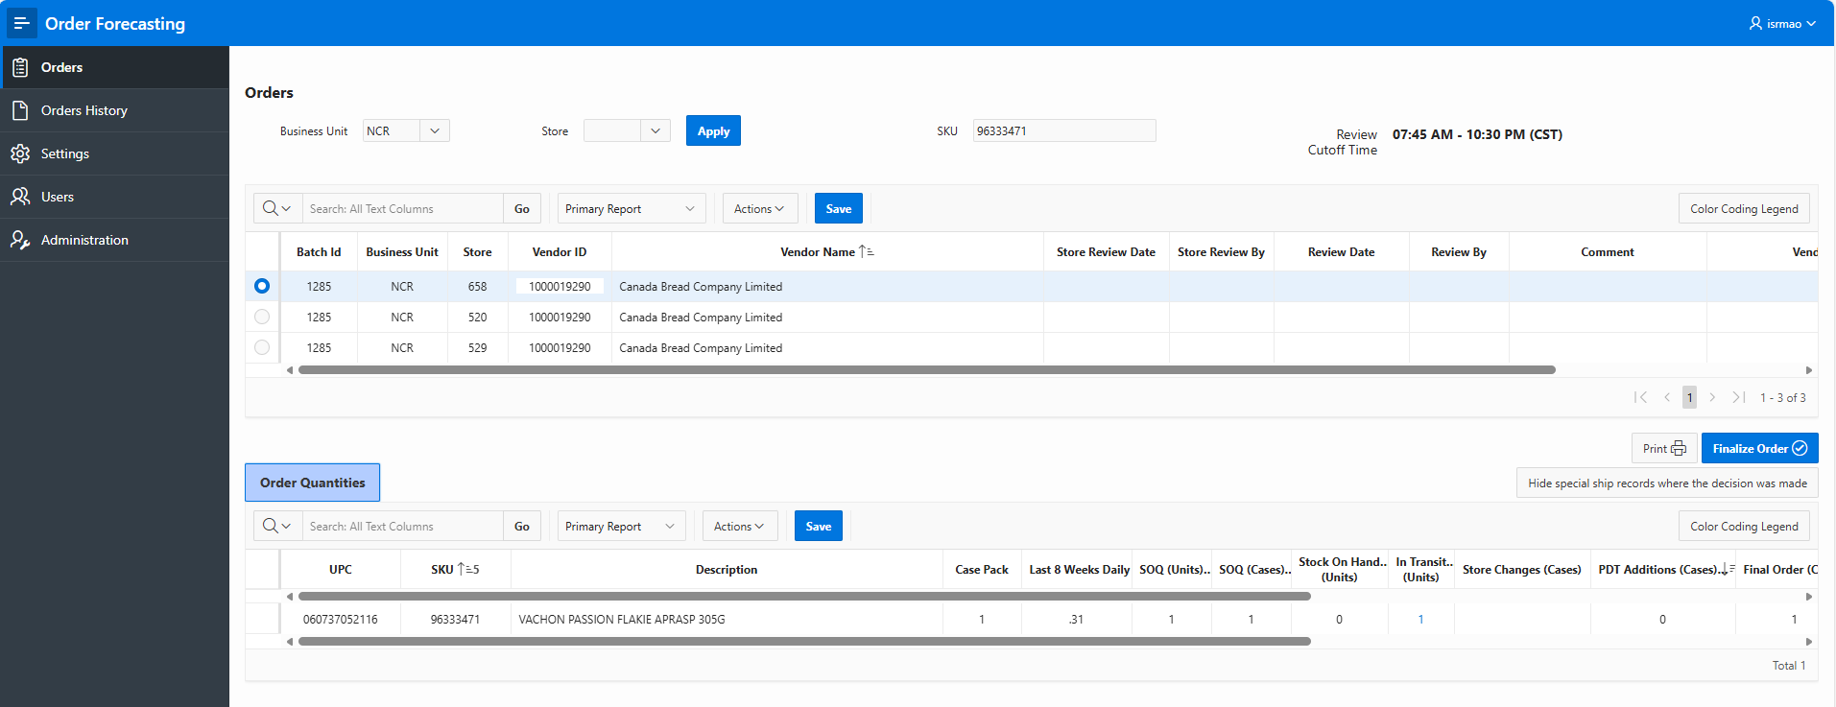
Search by SKU on all vendors for review in Order History
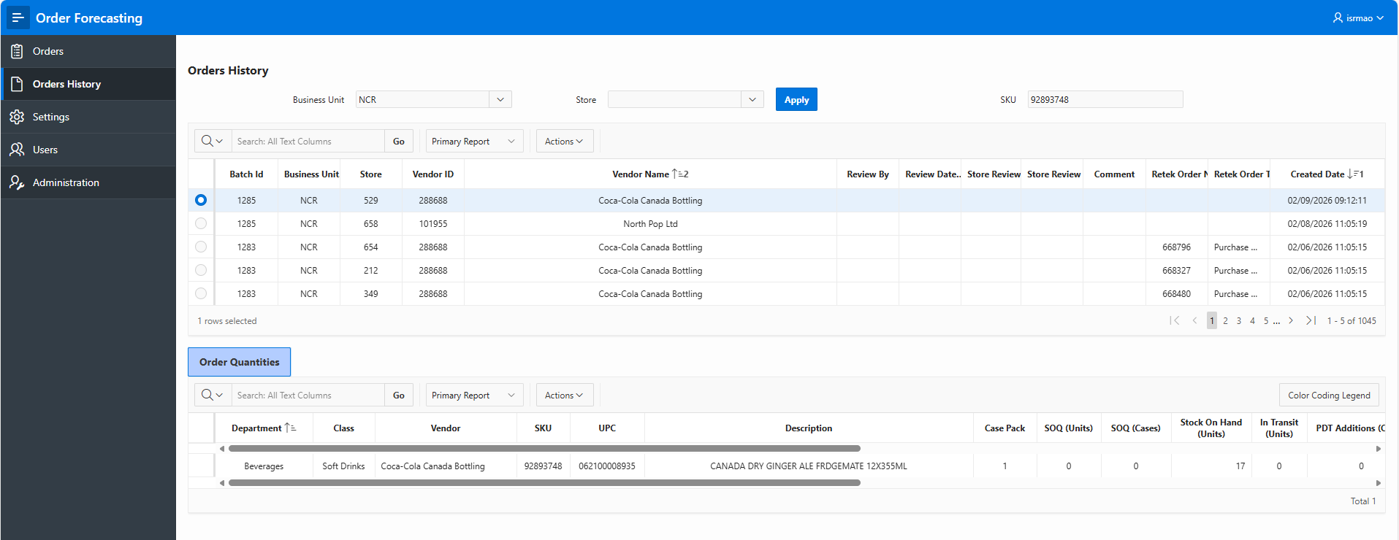
Only the item for the selected store shows in Order Quantities table if the item is found.
The vendor list table is also filtered based on the SKU search results.
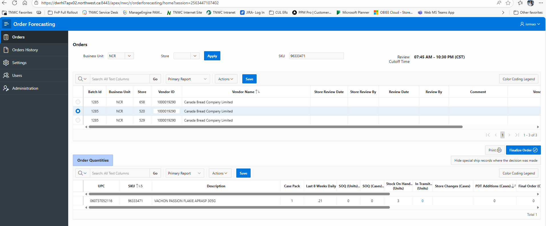
If the item is not in the master list, a message is shown accordingly.
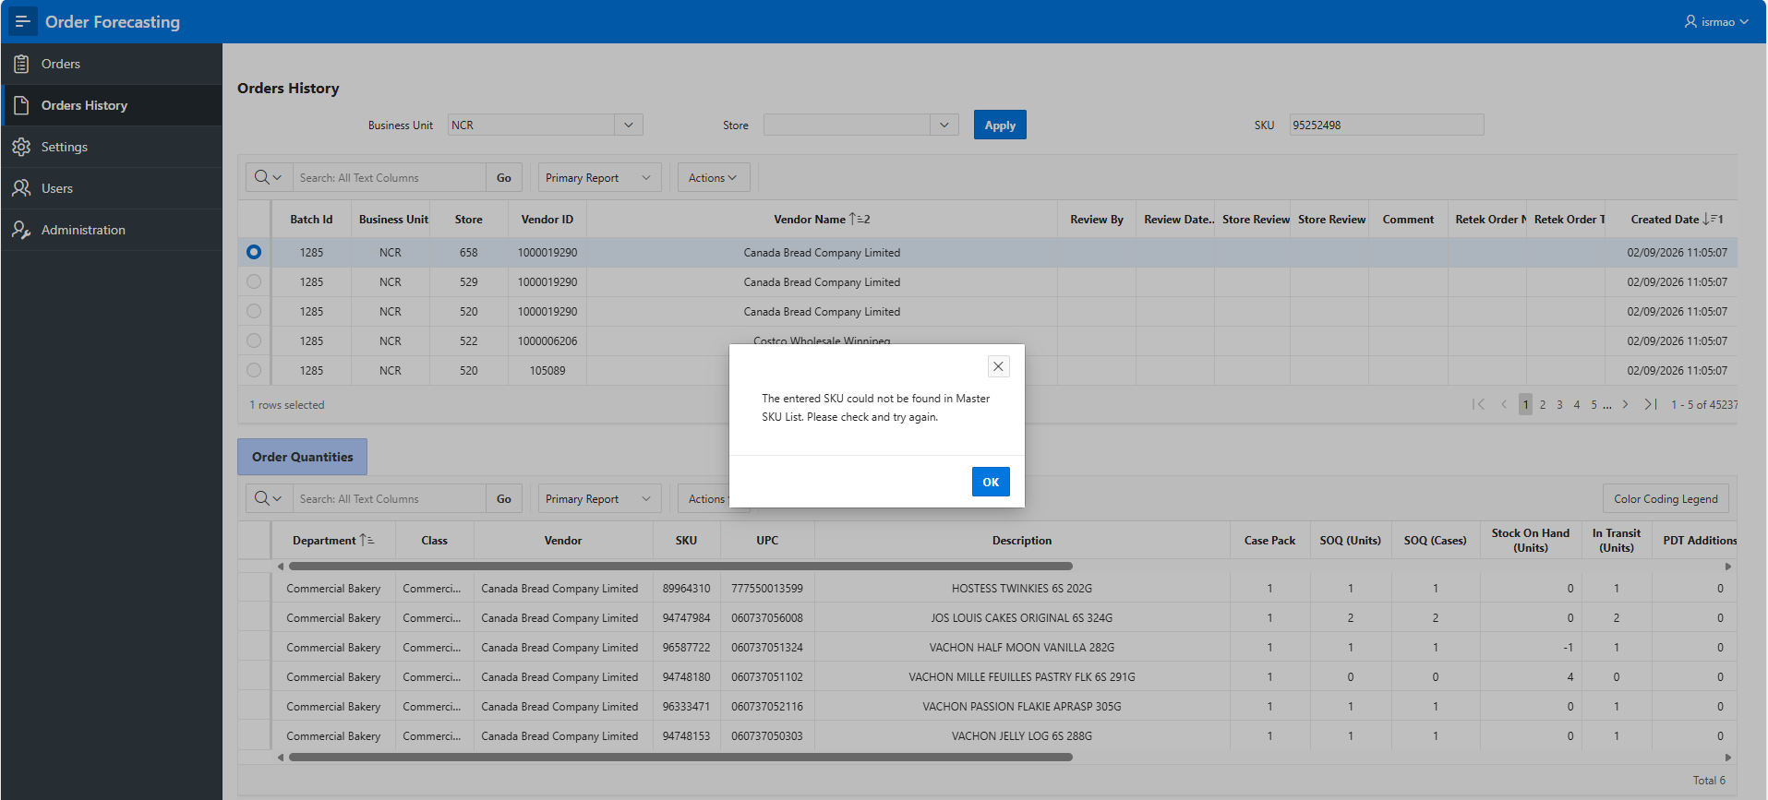
Similar search is available in Order History screen as well.
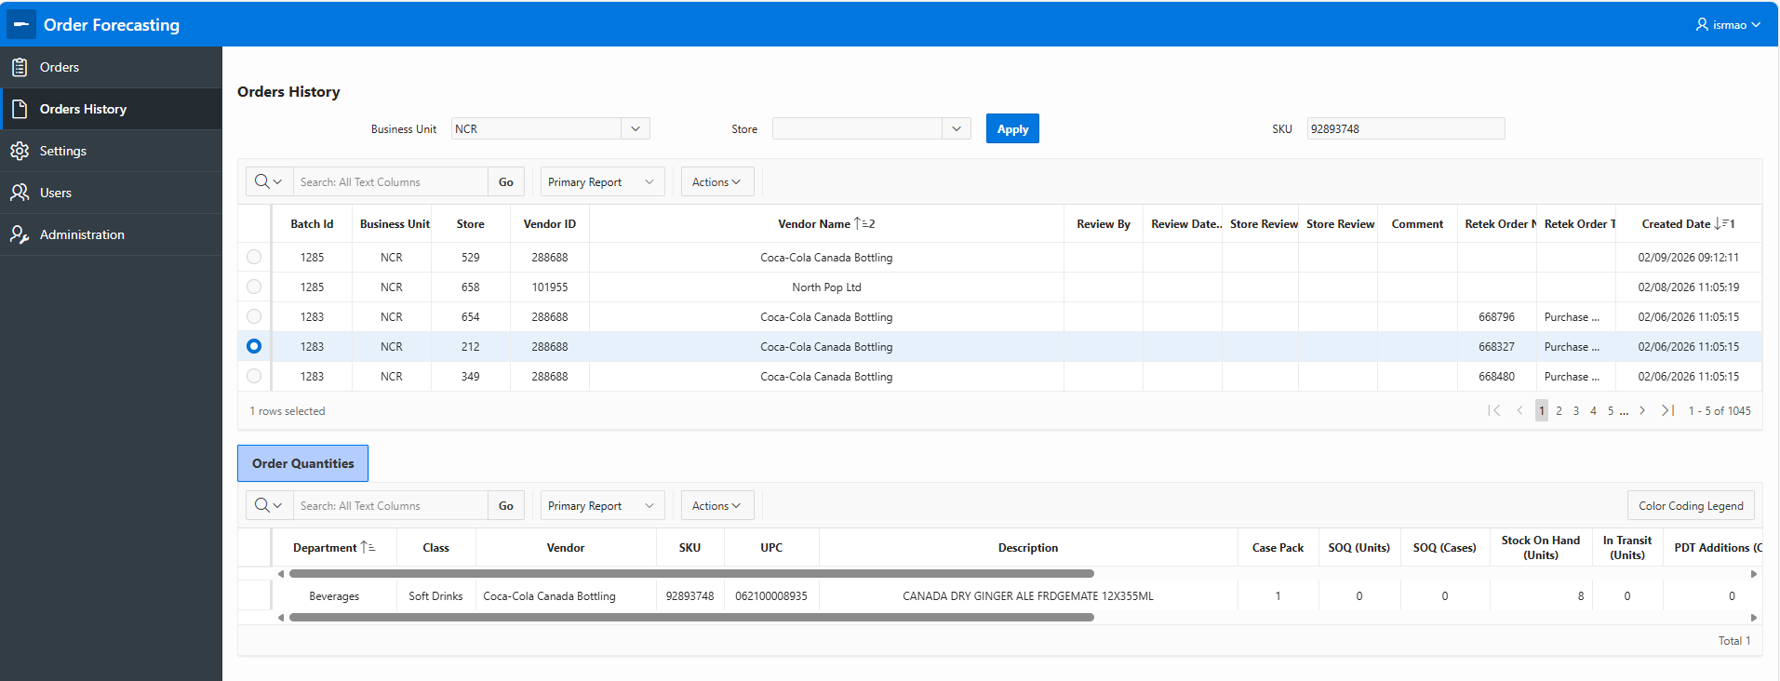

FR-690 Add On application enhancement - add alerts for items in today's review
Alert-1 is shown when the items is in for review today
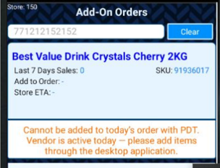

Alert-2 when review date has passed and order cut off date is today, but the cutoff time has not passed
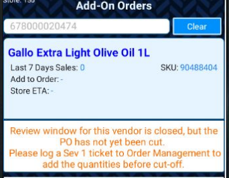

FR-694 UI - Simplify templates – Columns have been rearranged.
Order History Tab shows store user the created date
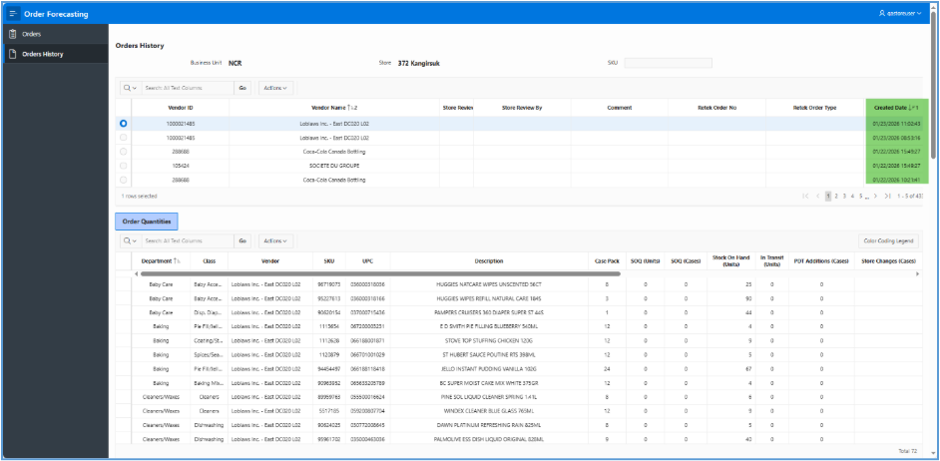
Previously a different user log in layout
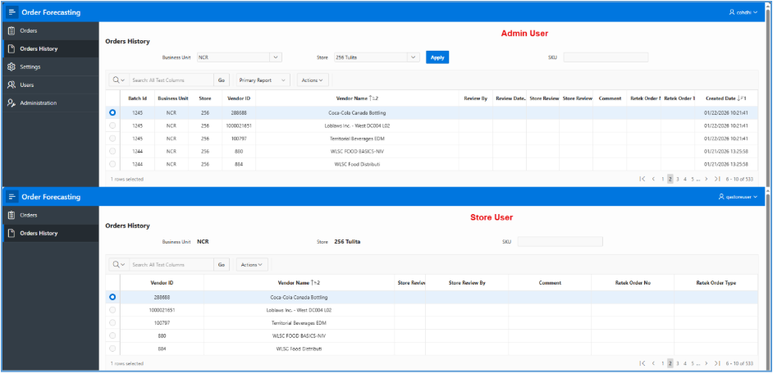
"Wait for Next Special Ship” renamed to “Special Ship instructions,” column only shows for special ship stores, is hidden for regular stores
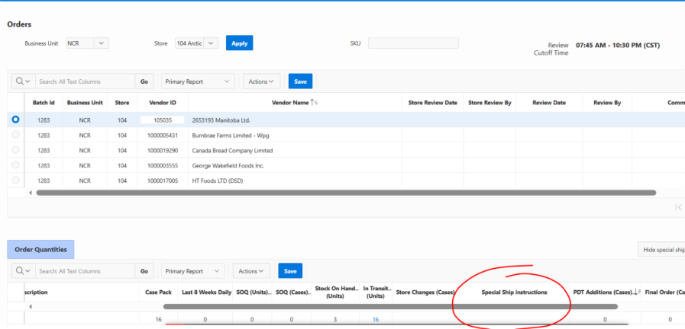
Order Quantities are sorted by PDT Additions first, Red Line items second, and remaining rows last
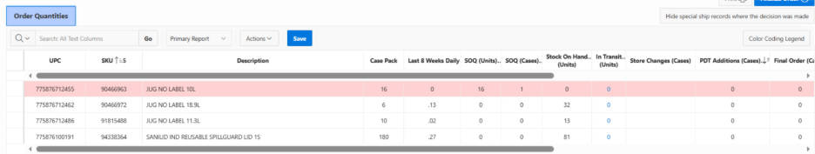
"Last 8 Weeks Daily Sales Average" column added (1)
"Reason for Changes" and "Unit Cost" column removed
"ETA DTM" renamed to ETA to Store (2)
Department and Class columns moved to beside description (3)
Item information (UPC, Description, SKU) appears first (4)
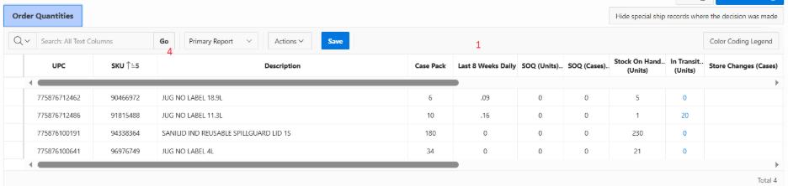

FR-699 UI - Improve special ship visibility.

Special ship related columns are shown only for special ship stores. New option “Hold for next order cycle available”
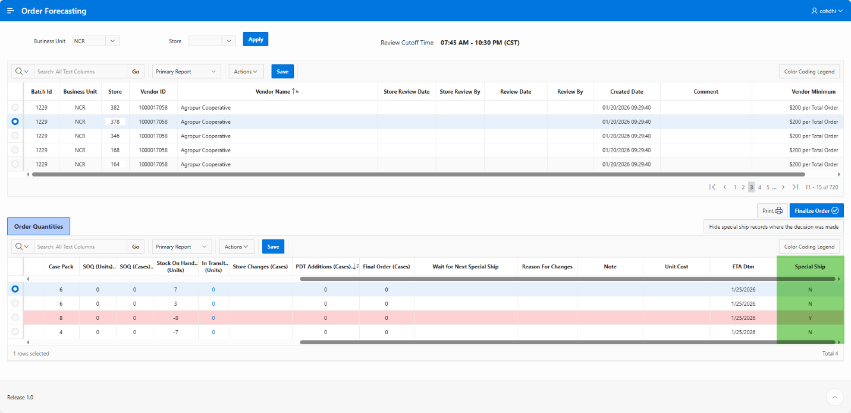
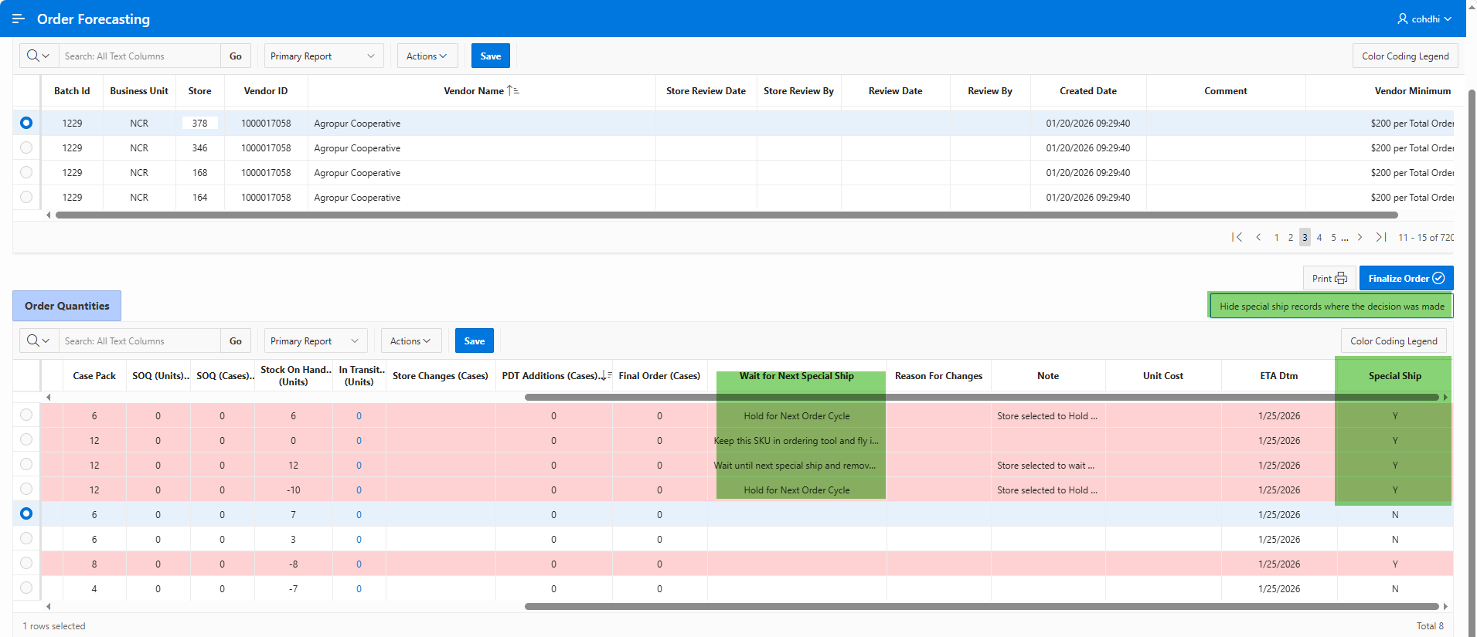
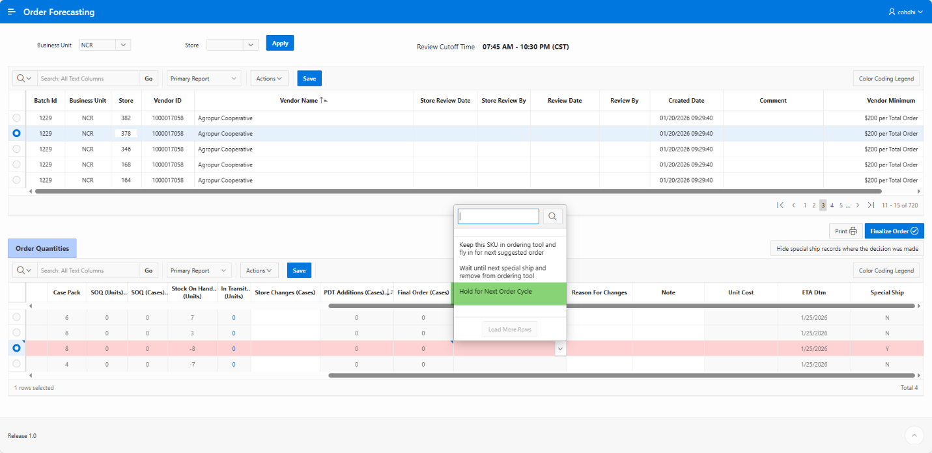

FR-702 UI - Flag new items – “New Item” column has been added.
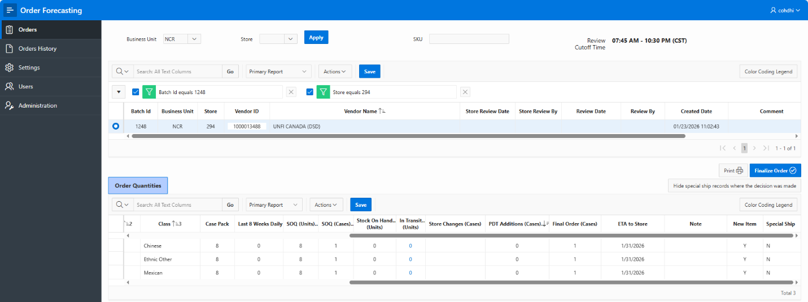
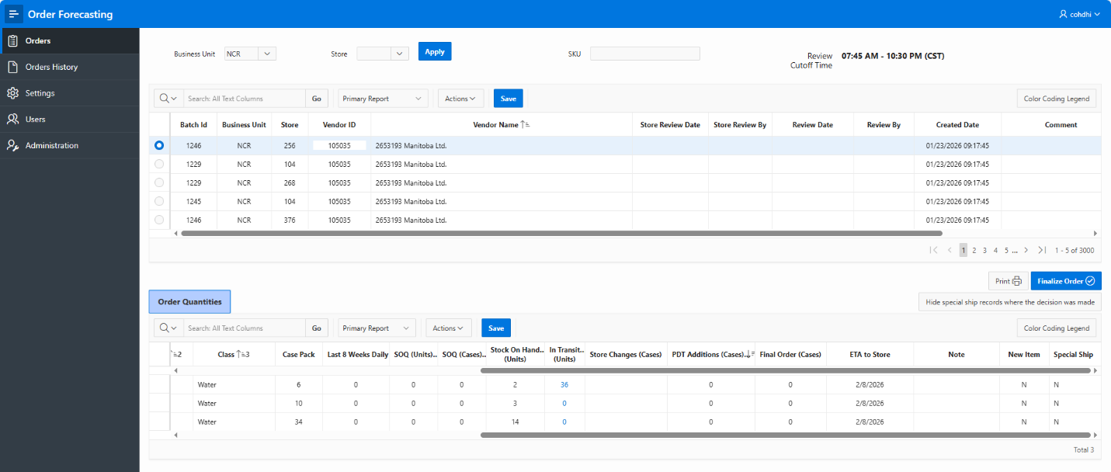

FR-724 UI – Display “Orders” Header When the Orders Tab Is Selected (same behavior as Order History tab)
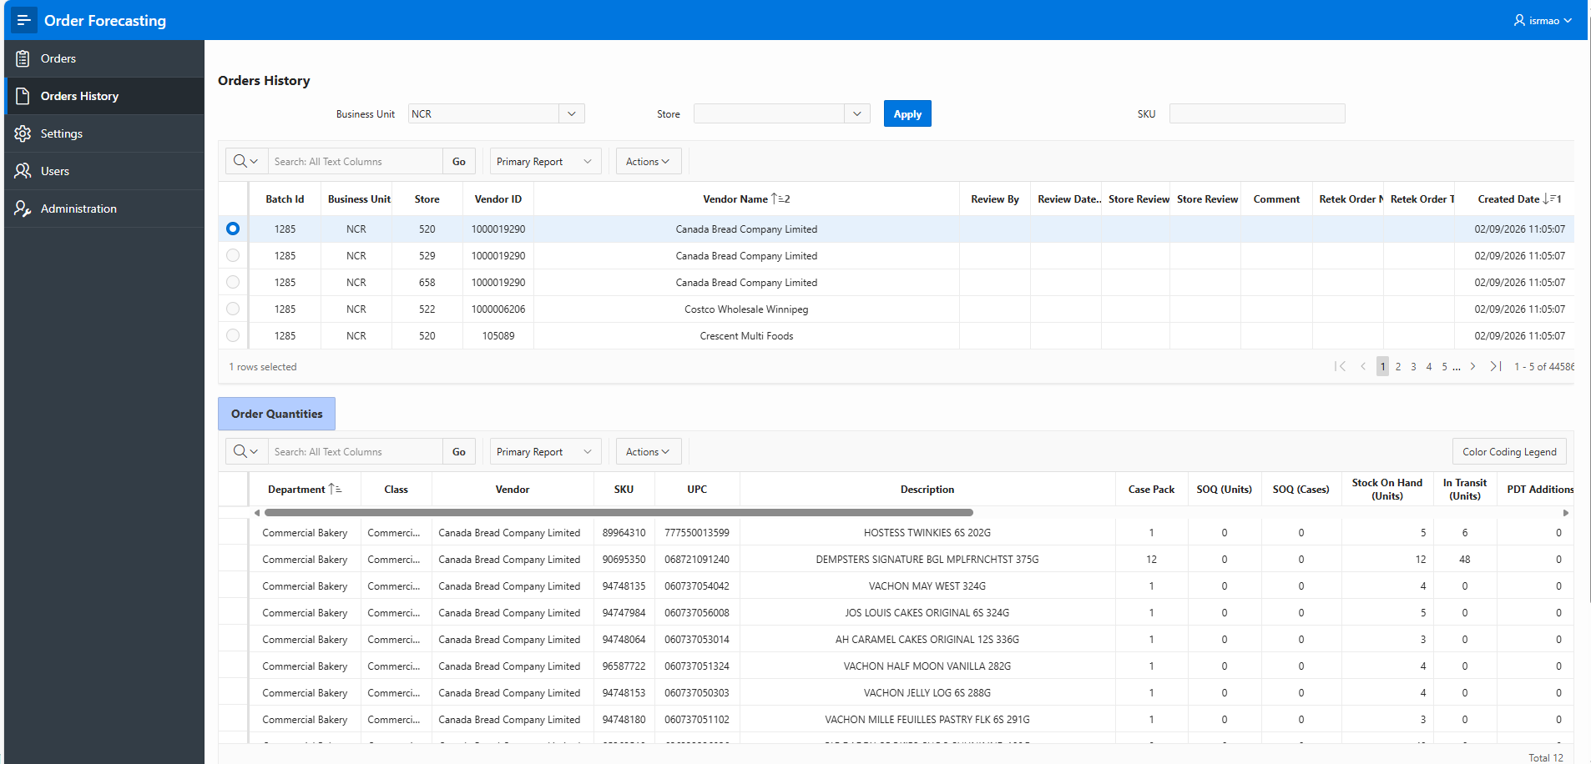
Display “Orders” Header When the Orders Tab Is Selected. It is same behavior as Order History tab above.
